Ans1:-
Frontend Development:
It focuses on what users see and interact with — the design, buttons, and layout of a website or app.
Example: The login page.
Backend Development:
It handles what happens behind the scenes — servers, databases, and application logic.
Example: When you log in to Instagram, the backend checks your username and password in the database.
Full-Stack Development:
A full-stack developer works on both frontend and backend, building the complete web application.
Example: A full-stack developer can build the whole food delivery app — from the user interface to the database that stores orders.

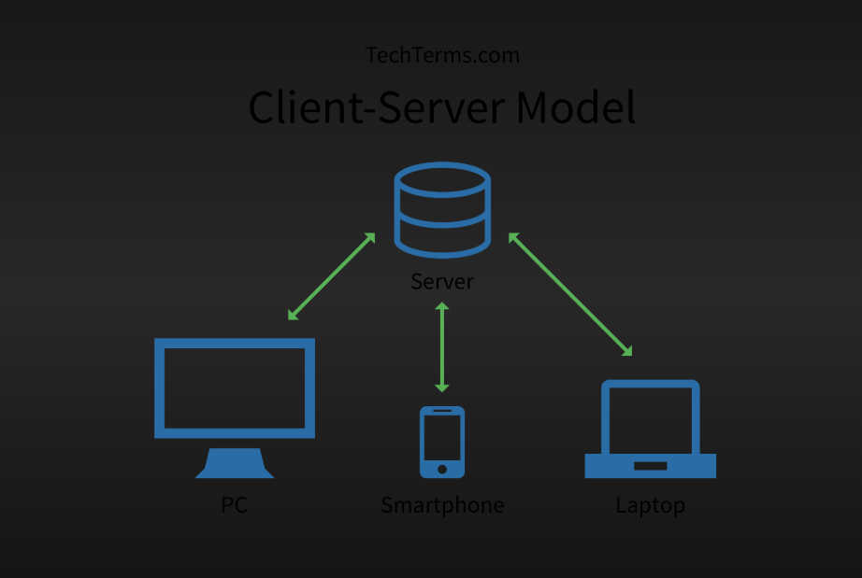
Ans2:-

Ans3:-
Enter URL: User types a website address in the browser.
DNS Lookup: Browser converts the domain name into the server’s IP address.
Send HTTP Request: Browser asks the server for the page.
Server Response: Server sends HTML, CSS, JS, and other resources.
Render Page: Browser processes the files and displays the web page.
Ans4:-
Code Editor / IDE (e.g., VS Code) – Write and manage code.
Web Browser (e.g., Chrome) – Test and view web pages.
Version Control (e.g., Git, GitHub) – Track changes and collaborate.
Package Manager (e.g., npm) – Manage libraries and dependencies.
Local Server / Runtime (e.g., Node.js, XAMPP) – Run backend code locally.
Database (e.g., MySQL, MongoDB) – Store and manage data.
Browser Developer Tools – Debug and inspect code.
Frameworks / Libraries (e.g., React) – Speed up development and structure code.

Ans5:-
A web server is software that stores, processes, and delivers web pages to users over the internet. When a browser requests a page via HTTP/HTTPS, the web server responds with the requested HTML, CSS, JavaScript, or other resources so the page can be displayed and the functions of the web server are:-
- Receives requests from clients (browsers)
- Processes the requests
- Sends back the appropriate web content
- Can host static pages (HTML, CSS) or dynamic pages (via backend scripts)

Ans6:-
Frontend Developer: Builds the website’s user interface and handles interactivity.
Example: Designing homepage and navigation or designing the UI interface.
Backend Developer: Manages server-side logic and connects frontend with the database.
Example: Processing orders and user logins.
Database Administrator (DBA): Maintains the database, ensuring data is stored securely and efficiently.
Example: Managing product and user data.

Ans7:-
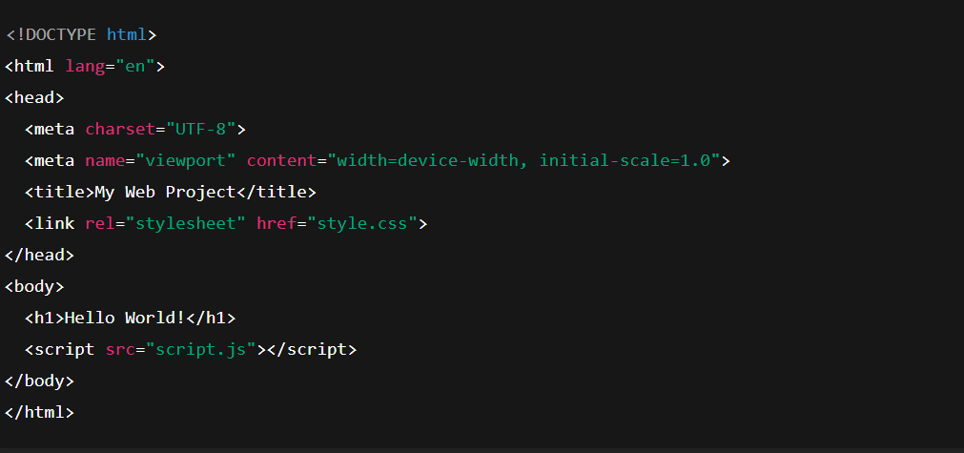

Ans8:-
Static Website: Fixed content that doesn’t change unless manually updated.
Example: Personal portfolio site.
Dynamic Website: Content changes based on user interaction or database data.
Example: Facebook or Amazon.

Ans9:-
Google Chrome
Mozilla Firefox
Microsoft Edge
Safari
Opera

Ans10:-
